RA 2013-5-10上线至今遗留问题

* 1. RA系统,不同的客户端(电脑),部门下拉框下拉时出现问题  
     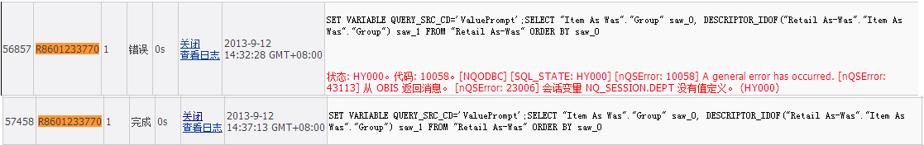  
     A电脑上部门下拉框可以正常显示,B电脑上部门下拉框却一直显示”请稍候…”,B电脑上试过不同浏览器(IE\Chrome\Firefox),结果都一样.
  2. RA建模问题:按类别查询有销售无库存单品数和有库存无销售单品数,这样的数据在事实中没有.
  3. RA系统中已有的账号，授予RA新建的权限，授予后，登录界面后，不会显示出来。把以后用户账号删除，然后从新授权，RA新建权限仍然不会显示出来。原因：需要再RA系统的服务器上，删除用户的文件夹，然后再重新登录，才会出来。
  4. 无法通过角色组对仪表盘进行权限控制
  5. RA系统raadmin用户查询某报表的会话日志经常报错：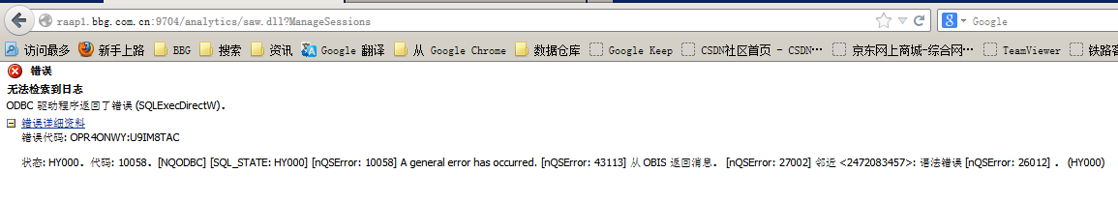

从高晶了解到，此BUG需要打补丁，要求下载OBIEE 11.1.1.6.2 BP1，网址：<https://support.oracle.com/epmos/faces/DocumentDisplay?_afrLoop=298282611768397&id=1464133.1&displayIndex=1&_afrWindowMode=0&_adf.ctrl-state=6dtfo12yr_149>

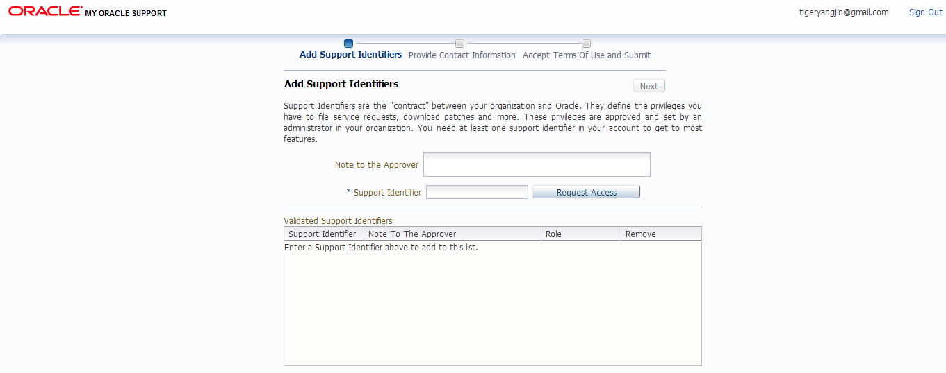

但是需要Support Identifier才能下载。

* 1. RA系统中的登录账号如何锁定?
  2. ODI接口问题:有时候rms的商品资料会有部分没有传送到ra系统,导致这部分商品的销售也不会传送ra系统,造成RMS销售和RA销售不一致.在上线前期出现比较频繁，现在出现这个问题少了。
  3. RA系统中报表的行数限制在5w行数据以内,而目前业务部门有不少数据都要求到明细,需要手工提取.
  4. RA中按月汇总的销售表，都是通过创建物化视图来展现的，但是缺点是，随着时间的推移，创建物化视图所需要的时间越来越长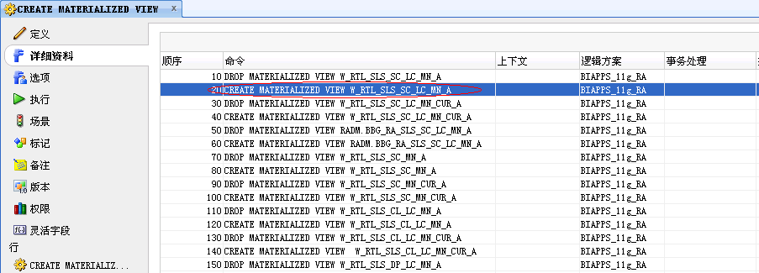
  5. RA中销售与供应商销售存在差异:  
     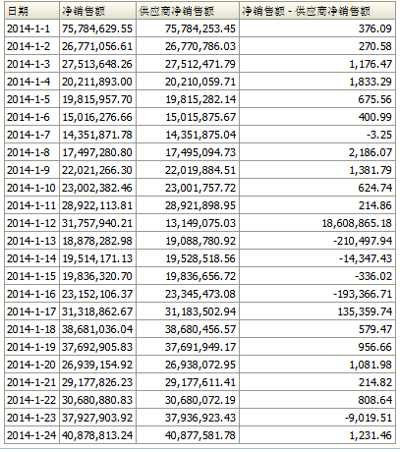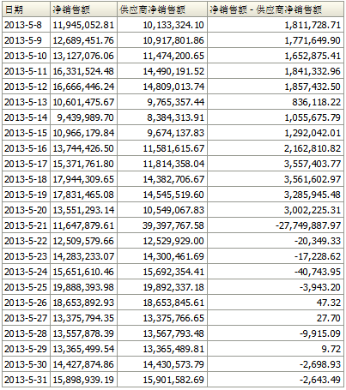
  6. 2014-06-12晚，UC4报错：PRDHIERSDE.KSH执行显示黄色，但是ODI中没有报错的会话，重启PRDHIERSDE.KSH则继续执行下去了。  
     *********************************************************************

**** ucxjli3m version 9.00A patchlevel 211-841 ****

** JOB 09760013 (ProcID:0000028063) START AT 13.06.2014 / 01:16:31 **

** UTC TIME 12.06.2014 / 17:16:31 **

** TEXT=" Job started " **

*********************************************************************

---------------------------------------------------------------------

Executable Directory is /u01/app/oretail/sit/13.2/ra/src

Executable is prdhiersde.ksh

Environment to source is /u01/app/oretail/sit/13.2/ra/etc/ra.env

Input Directory is /u01/app/oretail/sit/13.2/ra

Output Directory is /u01/app/oretail/sit/13.2/ra/log

---------------------------------------------------------------------

---------------------------------------------------------------------

Exception in thread "main" java.lang.OutOfMemoryError

at java.util.zip.ZipFile.open(Native Method)

at java.util.zip.ZipFile.<init>(ZipFile.java:127)

at java.util.jar.JarFile.<init>(JarFile.java:135)

at java.util.jar.JarFile.<init>(JarFile.java:72)

at sun.misc.URLClassPath$JarLoader.getJarFile(URLClassPath.java:646)

at sun.misc.URLClassPath$JarLoader.access$600(URLClassPath.java:540)

at sun.misc.URLClassPath$JarLoader$1.run(URLClassPath.java:607)

at java.security.AccessController.doPrivileged(Native Method)

at sun.misc.URLClassPath$JarLoader.ensureOpen(URLClassPath.java:599)

at sun.misc.URLClassPath$JarLoader.<init>(URLClassPath.java:583)

at sun.misc.URLClassPath$3.run(URLClassPath.java:333)

at java.security.AccessController.doPrivileged(Native Method)

at sun.misc.URLClassPath.getLoader(URLClassPath.java:322)

at sun.misc.URLClassPath.getLoader(URLClassPath.java:299)

at sun.misc.URLClassPath.getResource(URLClassPath.java:168)

at java.net.URLClassLoader$1.run(URLClassLoader.java:194)

at java.security.AccessController.doPrivileged(Native Method)

at java.net.URLClassLoader.findClass(URLClassLoader.java:190)

at java.lang.ClassLoader.loadClass(ClassLoader.java:306)

at sun.misc.Launcher$AppClassLoader.loadClass(Launcher.java:301)

at java.lang.ClassLoader.loadClass(ClassLoader.java:247)

Could not find the main class: oracle.odi.StartScen. Program will exit.

*********************************************************************

**** ucxjli3m version 9.00A patchlevel 211-841 ****

** JOB 09760013 (ProcID:0000028063) ENDED AT 13.06.2014 / 01:16:32 **

** UTC TIME 12.06.2014 / 17:16:32 **

** TEXT=" Job ended " RETCODE=01 **

*********************************************************************

* 1. 2014-06-14晚ODI报错，处理办法：RADM中：TRUNCATE RADM.C_LOAD_DATES,在UC4中，重启ksh运行成功。  
     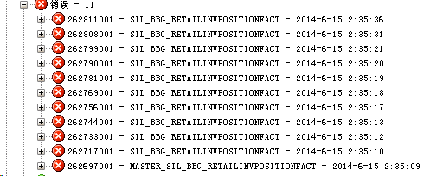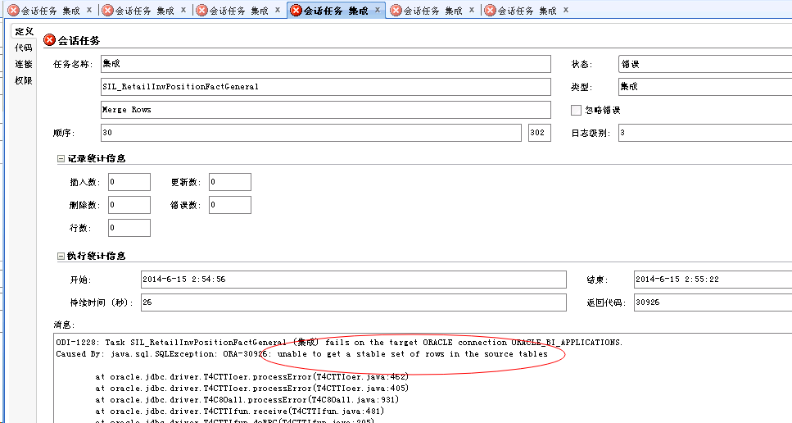

1. ODI不定期的会报错：  
   *********************************************************************  
   ****           ucxjli3m   version 9.00A  patchlevel 211-841      ****  
   ** JOB 10782038 (ProcID:0000026696) START AT 01.08.2014 / 04:46:58 **  
   **                                  UTC TIME 31.07.2014 / 20:46:58 **  
   ** TEXT="        Job started             "                         **  
   *********************************************************************  
   ---------------------------------------------------------------------  
   Executable Directory is /u01/app/oretail/sit/13.2/ra/src  
   Executable is bbg_ra_item_loc_sde.ksh  
   Environment to source is /u01/app/oretail/sit/13.2/ra/etc/ra.env  
   Input Directory is /u01/app/oretail/sit/13.2/ra  
   Output Directory is /u01/app/oretail/sit/13.2/ra/log  
   ---------------------------------------------------------------------  
   ---------------------------------------------------------------------  
   LOADING TABLE=BBG_RA_ITEM_LOC_DS  
   Exception in thread "main" java.lang.OutOfMemoryError  
        at java.util.zip.ZipFile.open(Native Method)  
        at java.util.zip.ZipFile.<init>(ZipFile.java:127)  
        at java.util.jar.JarFile.<init>(JarFile.java:135)  
        at java.util.jar.JarFile.<init>(JarFile.java:72)  
        at sun.misc.URLClassPath$JarLoader.getJarFile(URLClassPath.java:646)  
        at sun.misc.URLClassPath$JarLoader.access$600(URLClassPath.java:540)  
        at sun.misc.URLClassPath$JarLoader$1.run(URLClassPath.java:607)  
        at java.security.AccessController.doPrivileged(Native Method)  
        at sun.misc.URLClassPath$JarLoader.ensureOpen(URLClassPath.java:599)  
        at sun.misc.URLClassPath$JarLoader.<init>(URLClassPath.java:583)  
        at sun.misc.URLClassPath$3.run(URLClassPath.java:333)  
        at java.security.AccessController.doPrivileged(Native Method)  
        at sun.misc.URLClassPath.getLoader(URLClassPath.java:322)  
        at sun.misc.URLClassPath.getLoader(URLClassPath.java:299)  
        at sun.misc.URLClassPath.getResource(URLClassPath.java:168)  
        at java.net.URLClassLoader$1.run(URLClassLoader.java:194)  
        at java.security.AccessController.doPrivileged(Native Method)  
        at java.net.URLClassLoader.findClass(URLClassLoader.java:190)  
        at java.lang.ClassLoader.loadClass(ClassLoader.java:306)  
        at sun.misc.Launcher$AppClassLoader.loadClass(Launcher.java:301)  
        at java.lang.ClassLoader.loadClass(ClassLoader.java:247)  
   Could not find the main class: oracle.odi.StartScen.  Program will exit.  
   *********************************************************************  
   ****           ucxjli3m   version 9.00A  patchlevel 211-841      ****  
   ** JOB 10782038 (ProcID:0000026696) ENDED AT 01.08.2014 / 04:46:58 **  
   **                                  UTC TIME 31.07.2014 / 20:46:58 **  
   ** TEXT="        Job ended               "  RETCODE=01             **  
   *********************************************************************
2. SDE_RetailSalesPromotionTransactionFact随后报错：  
   ODI-1228: Task SDE_RetailSalesPromotionTransactionFact (集成) fails on the target ORACLE connection ORACLE_BI_APPLICATIONS.  
   Caused By: java.sql.SQLException: IO Error: Socket read timed out  
        at oracle.odi.jdbc.datasource.LoginTimeoutDatasourceAdapter.doGetConnection(LoginTimeoutDatasourceAdapter.java:133)  
        at oracle.odi.jdbc.datasource.LoginTimeoutDatasourceAdapter.getConnection(LoginTimeoutDatasourceAdapter.java:62)  
        at oracle.odi.core.datasource.dwgobject.support.OnConnectOnDisconnectDataSourceAdapter.getConnection(OnConnectOnDisconnectDataSourceAdapter.java:74)  
        at org.springframework.jdbc.datasource.DataSourceUtils.doGetConnection(DataSourceUtils.java:113)  
        at com.sunopsis.sql.SnpsConnection.createConnection(SnpsConnection.java:390)  
        at com.sunopsis.sql.SnpsConnection.connect(SnpsConnection.java:348)  
        at com.sunopsis.dwg.dbobj.SnpSessTaskSql.getExecutor(SnpSessTaskSql.java:2962)  
        at com.sunopsis.dwg.dbobj.SnpSessTaskSql.processTask(SnpSessTaskSql.java:2901)  
        at com.sunopsis.dwg.dbobj.SnpSessTaskSql.treatTask(SnpSessTaskSql.java:2625)  
        at com.sunopsis.dwg.dbobj.SnpSessStep.treatAttachedTasks(SnpSessStep.java:558)  
        at com.sunopsis.dwg.dbobj.SnpSessStep.treatSessStep(SnpSessStep.java:464)  
        at com.sunopsis.dwg.dbobj.SnpSession.treatSession(SnpSession.java:2093)  
        at com.sunopsis.dwg.dbobj.SnpSession.treatSession(SnpSession.java:1889)  
        at oracle.odi.runtime.agent.processor.impl.StartScenRequestProcessor$2.doAction(StartScenRequestProcessor.java:580)  
        at oracle.odi.core.persistence.dwgobject.DwgObjectTemplate.execute(DwgObjectTemplate.java:216)  
        at oracle.odi.runtime.agent.processor.impl.StartScenRequestProcessor.doProcessStartScenTask(StartScenRequestProcessor.java:513)  
        at oracle.odi.runtime.agent.processor.impl.StartScenRequestProcessor$StartScenTask.doExecute(StartScenRequestProcessor.java:1066)  
        at oracle.odi.runtime.agent.processor.task.AgentTask.execute(AgentTask.java:126)  
        at oracle.odi.runtime.agent.support.DefaultAgentTaskExecutor$2.run(DefaultAgentTaskExecutor.java:82)  
        at java.lang.Thread.run(Thread.java:662)  
   Caused by: java.sql.SQLRecoverableException: IO Error: Socket read timed out  
        at oracle.jdbc.driver.T4CConnection.logon(T4CConnection.java:482)  
        at oracle.jdbc.driver.PhysicalConnection.<init>(PhysicalConnection.java:678)  
        at oracle.jdbc.driver.T4CConnection.<init>(T4CConnection.java:238)  
        at oracle.jdbc.driver.T4CDriverExtension.getConnection(T4CDriverExtension.java:34)  
        at oracle.jdbc.driver.OracleDriver.connect(OracleDriver.java:567)  
        at oracle.odi.jdbc.datasource.DriverManagerDataSource.getConnectionFromDriver(DriverManagerDataSource.java:410)  
        at oracle.odi.jdbc.datasource.DriverManagerDataSource.getConnectionFromDriver(DriverManagerDataSource.java:386)  
        at oracle.odi.jdbc.datasource.DriverManagerDataSource.getConnectionFromDriver(DriverManagerDataSource.java:353)  
        at oracle.odi.jdbc.datasource.DriverManagerDataSource.getConnection(DriverManagerDataSource.java:332)  
        at oracle.odi.jdbc.datasource.LoginTimeoutDatasourceAdapter$ConnectionProcessor.run(LoginTimeoutDatasourceAdapter.java:217)  
        at java.util.concurrent.Executors$RunnableAdapter.call(Executors.java:441)  
        at java.util.concurrent.FutureTask$Sync.innerRun(FutureTask.java:303)  
        at java.util.concurrent.FutureTask.run(FutureTask.java:138)  
        at java.util.concurrent.ThreadPoolExecutor$Worker.runTask(ThreadPoolExecutor.java:886)  
        at java.util.concurrent.ThreadPoolExecutor$Worker.run(ThreadPoolExecutor.java:908)  
        ... 1 more  
   Caused by: oracle.net.ns.NetException: Socket read timed out  
        at oracle.net.ns.Packet.receive(Packet.java:341)  
        at oracle.net.ns.NSProtocol.connect(NSProtocol.java:308)  
        at oracle.jdbc.driver.T4CConnection.connect(T4CConnection.java:1222)  
        at oracle.jdbc.driver.T4CConnection.logon(T4CConnection.java:330)  
        ... 15 more
   1. RA**报表报错信息：  
      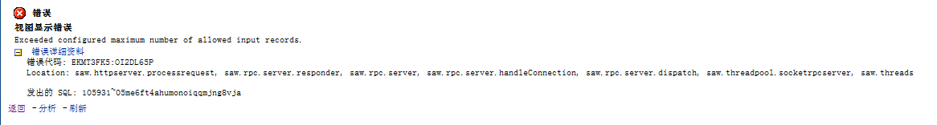oracle官网论坛**<https://community.oracle.com/thread/2461384?start=0&tstart=0>  
      BUG地址：

<https://support.oracle.com/rs?type=bug&id=14115879>

* 1. 业务部门要求在RA系统中可以出分经营属性（经销、代销）的周转报表，但是RADM中只有BBG_RA_ITEM_LOC_D上有经营属性（BUSINESS_MODE）。销售事实、库存事实的汇总表没有区分经营属性（BUSINESS_MODE）。所以分经营属性的报表只能从最细粒度（商品、地点）上关联BBG_RA_ITEM_LOC_D的USINESS_MODE。所以数据出来时间很长很长。
  2. RA系统之前可以使用CHROME浏览器登录，但是现在不能使用chrome浏览器了。日期菜单无法打开。  
     补丁程序17606196: MERGE REQUEST ON TOP OF OBIEE BP 11.1.1.7.1 FOR BUGS 17261933 16068402  
     